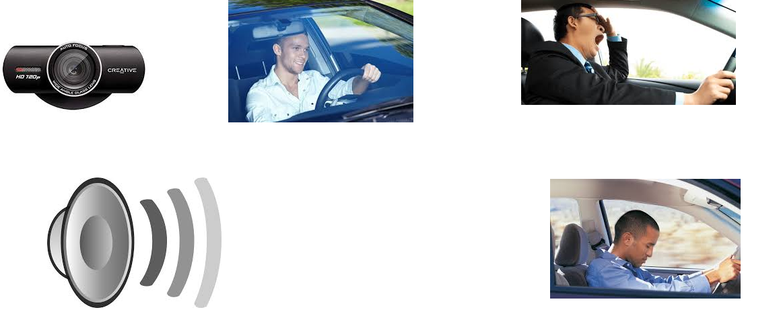
Sound
Mouth opening
head bending
Live

